1. 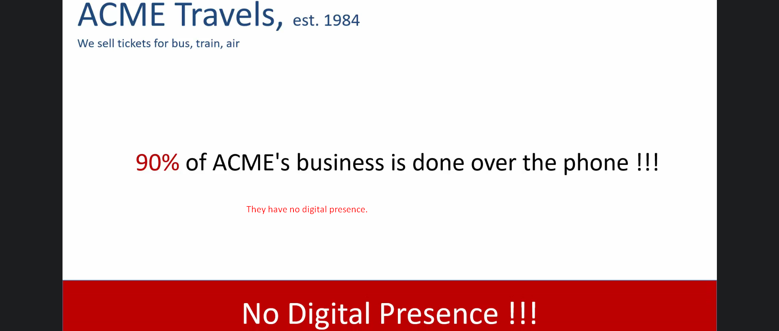
2. 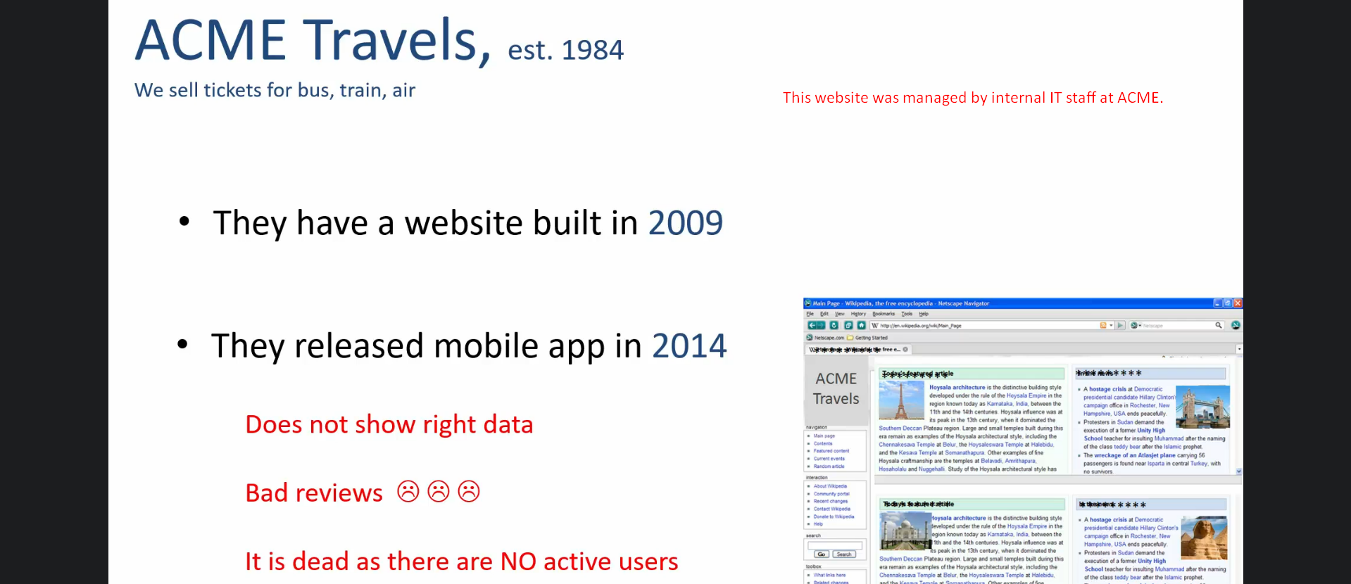
3. **Internal IT Staff, Digital Presence**
4. **ACME management** has a big concern at this time.
5. ACME has been consistently losing its **market share** to its **competitors**.

The biggest reason for this decline is because competition has adopted **digital technologies** to make their offerings more attractive to the customers.

1. 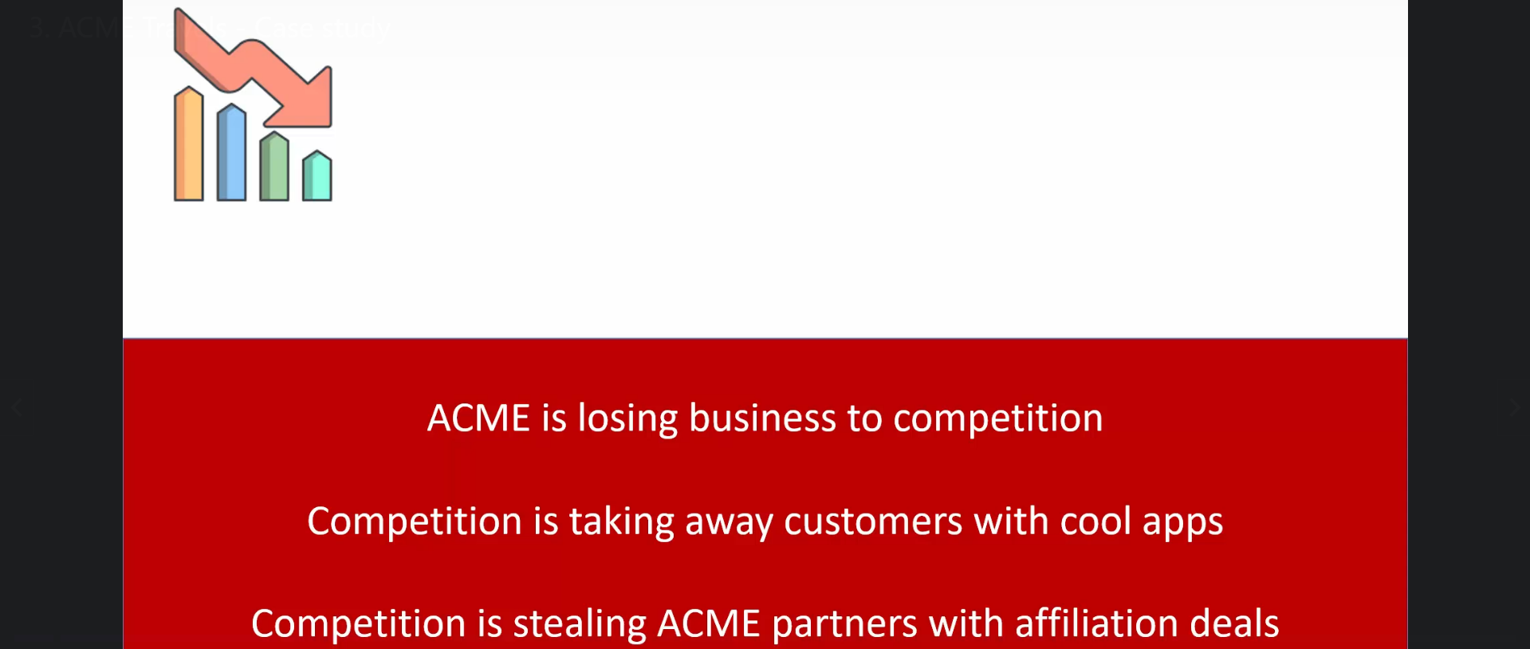
2. 